# Functions of a Random Variable

Review Section 2.8 in Goldsman, D. & Goldsman, P. (2020). A First Course in Probability and Statistics. Lulu. [Download link](https://www.lulu.com/search?page=1&q=goldsman&pageSize=10&adult_audience_rating=00)

Other resources that are helpful when reviewing probability and statisics are:

<https://www.probabilitycourse.com/>

[Khan Academy](https://www.khanacademy.org/)

[YouTube](https://www.youtube.com/results?search_query=probability+and+statistics)

<https://stats.libretexts.org/Bookshelves>

The concept of functions of a random variable is a fundamental topic in probability theory and statistics. It deals with transforming a random variable (RV) by applying a function to it, thus creating a new random variable. The original random variable represents a random process or phenomenon, while the new random variable represents the transformed or modified process. This transformation can provide insights into the behavior of the original random variable and help us better understand the underlying processes.

The importance of functions of a random variable lies in the fact that they enable us to:

* Simplify complex problems: Transforming a random variable often simplifies the problem at hand, making it easier to analyze and solve. This can be particularly helpful when dealing with multiple random variables or when the relationship between them is complicated.
* Model real-world processes: Many real-world processes can be represented by functions of random variables. This enables us to create mathematical models for these processes, which can be used to predict outcomes, optimize decision-making, and minimize risks.
* Derive statistical properties: Functions of random variables help us derive important statistical properties, such as expectation, variance, and covariance. These properties allow us to characterize and compare different random variables or processes.

Some concrete real-world applications of functions of random variables include:

* Insurance: In the insurance industry, functions of random variables are used to model risks and estimate the probability of events such as accidents, claims, and natural disasters. For example, the number of claims for an insurance company can be modeled as a random variable following a [Poisson distribution](https://en.wikipedia.org/wiki/Poisson_distribution), and the amount of each claim can be another random variable. The total cost of claims, which is a function of these two random variables, can then be used to determine premiums and assess the company's financial stability.
* [Quality control](https://en.wikipedia.org/wiki/Quality_control): In manufacturing processes, the quality of a product can be affected by various factors, such as temperature, pressure, and material properties. These factors can be modeled as random variables, and functions of these random variables can be used to determine the probability of producing a defective product. By monitoring and controlling these functions, manufacturers can improve product quality and reduce waste.
* [Signal processing](https://en.wikipedia.org/wiki/Signal_processing): In communication systems, the quality of a transmitted signal can be affected by factors such as noise, interference, and fading. The received signal can be modeled as a function of the transmitted signal (a random variable) and these factors (also random variables). By analyzing and processing these functions, engineers can improve the quality and reliability of communication systems.
* [Epidemiology](https://en.wikipedia.org/wiki/Epidemiology): In the study of diseases, functions of random variables are used to model the spread of infectious diseases and predict the number of infected individuals. The number of new infections can be modeled as a function of the current number of infected individuals (a random variable) and the probability of transmission (another random variable). These models can help guide public health interventions and inform policy decisions.
* Finance: In financial markets, asset prices, returns, and risks can be modeled as functions of random variables. For example, the return on a stock can be modeled as a function of the stock's price (a random variable) and other factors such as market conditions and company performance (also random variables). By analyzing these functions, investors can make informed decisions and manage their investment portfolios.

# Why are Functions of a Random Variable Important?

The concept of functions of a random variable is central to many aspects of simulation due to the necessity to transform or derive new random variables from existing ones. Understanding this concept is crucial for the following reasons:

* Transformation of Distributions: In simulations, it's often necessary to generate random variables that follow a specific distribution. If we know how to generate random variables from one distribution (like the uniform distribution), we can apply a function to transform them into random variables of another desired distribution.
* Model Complexity: Real-world models might require derived variables based on some primary random variables. For instance, in a financial model, if the interest rate is modeled as a random variable, the return on an investment could be a derived random variable – a function of the interest rate.
* System Responses: In many simulations, we're interested in the system's response to certain random inputs. The response itself can be seen as a function of a random variable. For example, in a structural engineering simulation, the deformation of a structure might be a function of a random load.
* Statistical Dependence: Understanding functions of random variables helps in understanding the relationships between multiple random variables. This is crucial when modeling dependencies or correlations in simulations.
* Performance Metrics: In simulations, performance metrics or outputs (like profit, loss, efficiency, or failure rate) can often be expressed as functions of random variables (inputs).
* Nonlinear Systems: Many real-world systems exhibit nonlinear behavior. When random inputs are passed through non-linear systems, the output's distribution can change in complex ways. Understanding functions of random variables helps in analyzing these scenarios.
* Reliability Analysis: When assessing the reliability or failure of a system, the failure criteria might be a function of several random variables. For instance, a machine might fail if temperature (a random variable) exceeds a certain threshold and if lubrication (another random variable) is below a certain level.
* Optimization under Uncertainty: In some scenarios, the objective function to be optimized is a function of random variables. Understanding its behavior is essential to find optimal solutions under uncertainty.
* Monte Carlo Methods: One of the core principles of Monte Carlo methods is to sample from a distribution and evaluate a function at the sampled points. Many times, this function will be a function of the random variable representing the distribution.
* Probability Distributions and Moments: The mean, variance, and other moments of a derived random variable can be evaluated based on the original random variable and the function applied. Understanding this relationship is crucial for statistical analysis in simulations.
* Decision Analysis: In decision-making simulations, the outcomes or payoffs often depend on random factors. The expected payoff or outcome becomes a function of these random variables.

The concept of functions of a random variable provides a bridge between input uncertainties (random variables) and the resultant behaviors or outputs in a system. It enhances the depth and breadth of simulations by allowing a more comprehensive exploration of relationships, dependencies, and transformations in stochastic models.

# Examples

If [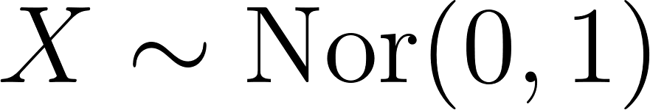](https://www.codecogs.com/eqnedit.php?latex=X%5Csim%20%5Ctext%7BNor%7D(0%2C%201)#0), then [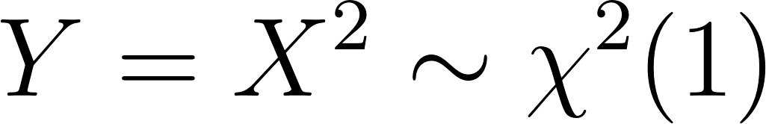](https://www.codecogs.com/eqnedit.php?latex=Y%3DX%5E2%20%5Csim%20%5Cchi%5E2(1)#0)

If [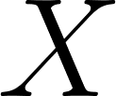](https://www.codecogs.com/eqnedit.php?latex=X#0) is a [standard normal random variable](https://en.wikipedia.org/wiki/Normal_distribution) (with a mean of 0 and a standard deviation of 1), then transforming [](https://www.codecogs.com/eqnedit.php?latex=X#0) by applying the function [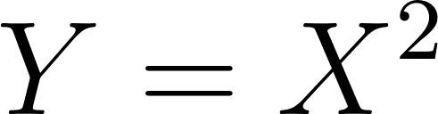](https://www.codecogs.com/eqnedit.php?latex=Y%20%3D%20X%5E2#0) results in a new random variable [](https://www.codecogs.com/eqnedit.php?latex=Y#0) that follows a chi-squared distribution with 1 degree of freedom ([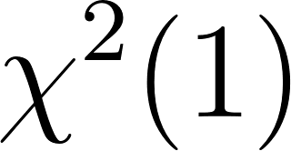](https://www.codecogs.com/eqnedit.php?latex=%5Cchi%5E2%20(1)#0)). The [chi-squared distribution](https://en.wikipedia.org/wiki/Chi-squared_distribution) is used in [hypothesis testing](https://en.wikipedia.org/wiki/Statistical_hypothesis_testing), analysis of the [sum of squares](https://en.wikipedia.org/wiki/Sum_of_squares), and has relationships with other distributions such as the [F-distribution](https://en.wikipedia.org/wiki/F-distribution) and [t-distribution](https://en.wikipedia.org/wiki/Student%27s_t-distribution) which are also widely used in hypothesis testing and the construction of [confidence intervals](https://en.wikipedia.org/wiki/Confidence_interval).

If [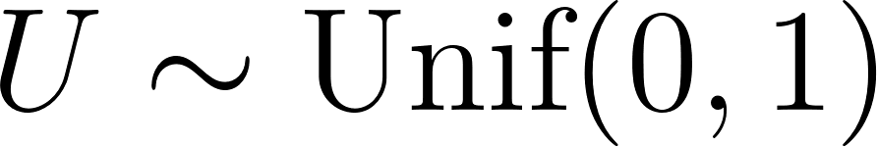](https://www.codecogs.com/eqnedit.php?latex=U%20%5Csim%20%5Ctext%7BUnif%7D(0%2C1)#0), then [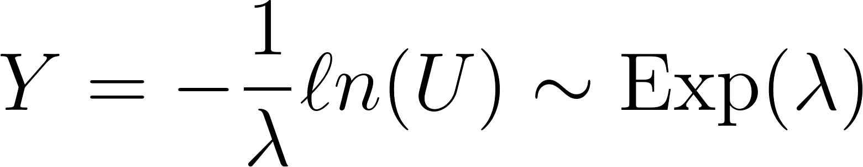](https://www.codecogs.com/eqnedit.php?latex=Y%3D-%5Cdfrac%7B1%7D%7B%5Clambda%7D%20%5Cell%20n(U)%20%5Csim%20%5Ctext%7BExp%7D(%5Clambda)#0).

This is the inverse transform method that shows how a uniform random variable can be used to generate exponential random variables. Refer back to M1L8 Generating Randomness, specifically the section on Generating Other RVs.

## Discrete Example

To construct the distribution of a function of a discrete random variable the following steps should be taken:

* Define the random variables. Identify the original discrete random variable [](https://www.codecogs.com/eqnedit.php?latex=X#0) and its probability mass function (PMF). Define the new random variable [](https://www.codecogs.com/eqnedit.php?latex=Y#0) as a function of [](https://www.codecogs.com/eqnedit.php?latex=X#0) (i.e., [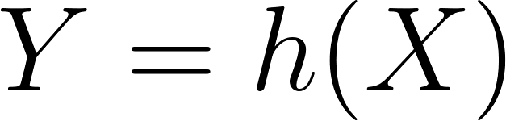](https://www.codecogs.com/eqnedit.php?latex=Y%3Dh(X)#0) where [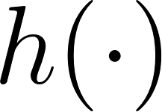](https://www.codecogs.com/eqnedit.php?latex=h(%5Ccdot)#0) is the function that transforms [](https://www.codecogs.com/eqnedit.php?latex=X#0).
* Determine the possible values that [](https://www.codecogs.com/eqnedit.php?latex=Y#0) can be. The values that [](https://www.codecogs.com/eqnedit.php?latex=Y#0) can be different from the values that [](https://www.codecogs.com/eqnedit.php?latex=X#0) be. For example if [](https://www.codecogs.com/eqnedit.php?latex=X#0) has the possible outcomes of [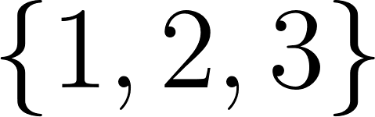](https://www.codecogs.com/eqnedit.php?latex=%5C%7B1%2C%202%2C%203%5C%7D#0) and [](https://www.codecogs.com/eqnedit.php?latex=Y%3DX%5E2#0), then [](https://www.codecogs.com/eqnedit.php?latex=Y#0) can take on the values of [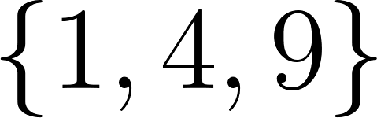](https://www.codecogs.com/eqnedit.php?latex=%5C%7B1%2C%204%2C%209%5C%7D#0)
* Calculate the probability mass function of [](https://www.codecogs.com/eqnedit.php?latex=Y#0). For each value [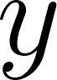](https://www.codecogs.com/eqnedit.php?latex=y#0) in possible outcomes of [](https://www.codecogs.com/eqnedit.php?latex=Y#0), calculate the probability [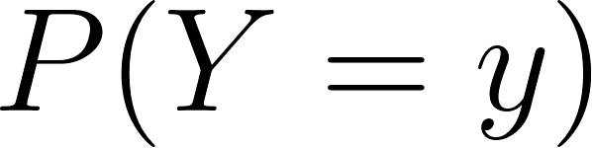](https://www.codecogs.com/eqnedit.php?latex=P(Y%20%3D%20y)#0) using the PMF of [](https://www.codecogs.com/eqnedit.php?latex=X#0) and the transformation [](https://www.codecogs.com/eqnedit.php?latex=h(%5Ccdot)#0). This can be done by identifying all the values of [](https://www.codecogs.com/eqnedit.php?latex=x#0) in the possible outcomes of [](https://www.codecogs.com/eqnedit.php?latex=X#0) for which [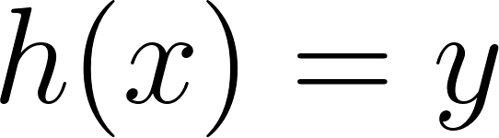](https://www.codecogs.com/eqnedit.php?latex=h(x)%3Dy#0) and then summing the probabilities [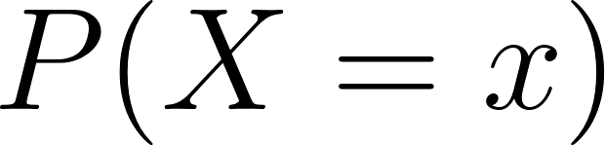](https://www.codecogs.com/eqnedit.php?latex=P(X%20%3D%20x)#0) for those values. The PMF of [](https://www.codecogs.com/eqnedit.php?latex=Y#0) can be expressed as [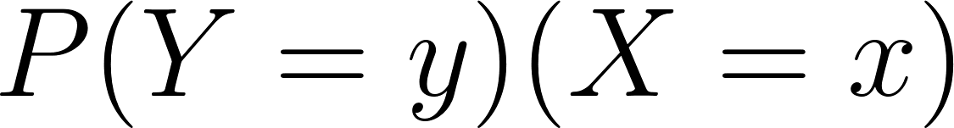](https://latex-staging.easygenerator.com/eqneditor/editor.php?latex=P(Y%3Dy)%5CsumP(X%3Dx)#0) for all [](https://www.codecogs.com/eqnedit.php?latex=x#0) such that [](https://www.codecogs.com/eqnedit.php?latex=h(x)%3Dy#0).

## Continuous Example

To construct the distribution of a function of a continuous random variable the following steps should be taken:

* Define the random variables. Identify the original continuous random variable [](https://www.codecogs.com/eqnedit.php?latex=X#0) and its probability density function (PDF) [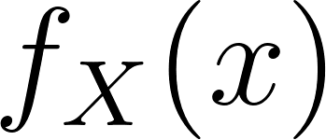](https://www.codecogs.com/eqnedit.php?latex=f_X(x)#0). Define the new random variable [](https://www.codecogs.com/eqnedit.php?latex=Y#0) as a function of [](https://www.codecogs.com/eqnedit.php?latex=X#0) (i.e., [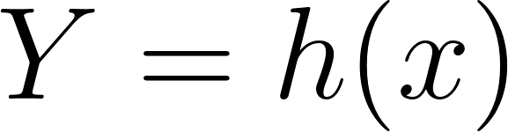](https://www.codecogs.com/eqnedit.php?latex=Y%3Dh(x)#0) where [](https://www.codecogs.com/eqnedit.php?latex=h(%5Ccdot)#0) is the function that transforms [](https://www.codecogs.com/eqnedit.php?latex=X#0))
* Identify the possible values that [](https://www.codecogs.com/eqnedit.php?latex=Y#0) can be. The possible values of [](https://www.codecogs.com/eqnedit.php?latex=Y#0) may be different from the range of [](https://www.codecogs.com/eqnedit.php?latex=X#0) due to the transformation. For example if the possible values that [](https://www.codecogs.com/eqnedit.php?latex=X#0) can take on are in [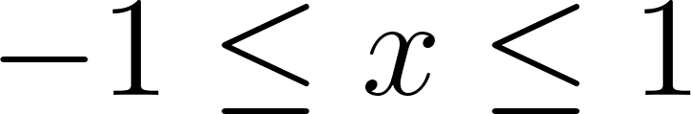](https://www.codecogs.com/eqnedit.php?latex=-1%20%5Cleq%20x%20%5Cleq%201#0) and [](https://www.codecogs.com/eqnedit.php?latex=Y%3DX%5E2#0) then the possible values that [](https://www.codecogs.com/eqnedit.php?latex=Y#0) can take on are in [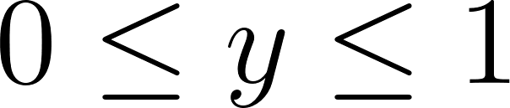](https://www.codecogs.com/eqnedit.php?latex=0%20%5Cleq%20y%20%5Cleq%201#0)
* Calculate the cumulative distribution (CDF) of [](https://www.codecogs.com/eqnedit.php?latex=Y#0), [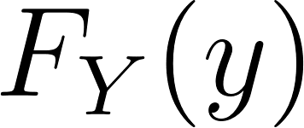](https://www.codecogs.com/eqnedit.php?latex=F_Y(y)#0) using the PDF of [](https://www.codecogs.com/eqnedit.php?latex=X#0) and the transformation function [](https://www.codecogs.com/eqnedit.php?latex=h(%5Ccdot)#0). The CDF of [](https://www.codecogs.com/eqnedit.php?latex=Y#0) can be found by integrating the PDF of [](https://www.codecogs.com/eqnedit.php?latex=X#0) over the appropriate range: [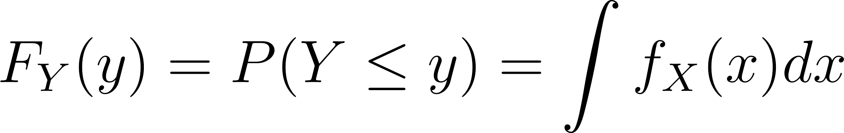](https://www.codecogs.com/eqnedit.php?latex=F_Y(y)%3DP(Y%20%5Cleq%20y)%3D%5Cint%20f_X(x)%20dx#0) over the range of [](https://www.codecogs.com/eqnedit.php?latex=x#0) such that [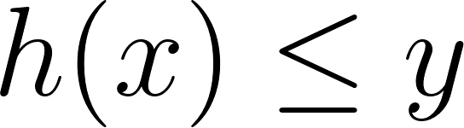](https://www.codecogs.com/eqnedit.php?latex=h(x)%20%5Cleq%20y#0)
* Calculate the PDF of [](https://www.codecogs.com/eqnedit.php?latex=Y#0) by taking the derivative of the CDF of [](https://www.codecogs.com/eqnedit.php?latex=Y#0).

Suppose [](https://www.codecogs.com/eqnedit.php?latex=X#0) has PDF [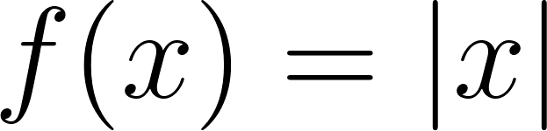](https://www.codecogs.com/eqnedit.php?latex=f(x)%3D%7Cx%7C#0), [](https://www.codecogs.com/eqnedit.php?latex=-1%20%5Cleq%20x%20%5Cleq%20%201#0). Find the PDF of [](https://www.codecogs.com/eqnedit.php?latex=Y%3DX%5E2#0)

Identify the possible values that [](https://www.codecogs.com/eqnedit.php?latex=Y#0) can be. Taking the square of the possible values of [](https://www.codecogs.com/eqnedit.php?latex=x#0) will make them all positive and in the range [](https://www.codecogs.com/eqnedit.php?latex=0%20%5Cleq%20y%20%5Cleq%201#0).

Calculate the CDF of [](https://www.codecogs.com/eqnedit.php?latex=Y#0).

[](https://www.codecogs.com/eqnedit.php?latex=F_Y(y)%3DP(Y%20%5Cleq%20y)%3DP(X%5E2%20%5Cleq%20y)#0)

In order to understand how to proceed, a graph of the function involved will help. The area under the curve we are interested in is between [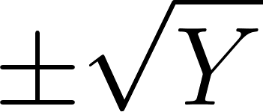](https://www.codecogs.com/eqnedit.php?latex=%5Cpm%20%5Csqrt%7BY%7D#0). Please visit [this link](https://www.desmos.com/calculator/hgtinh69g6) for an interactive graph showing this scenario.

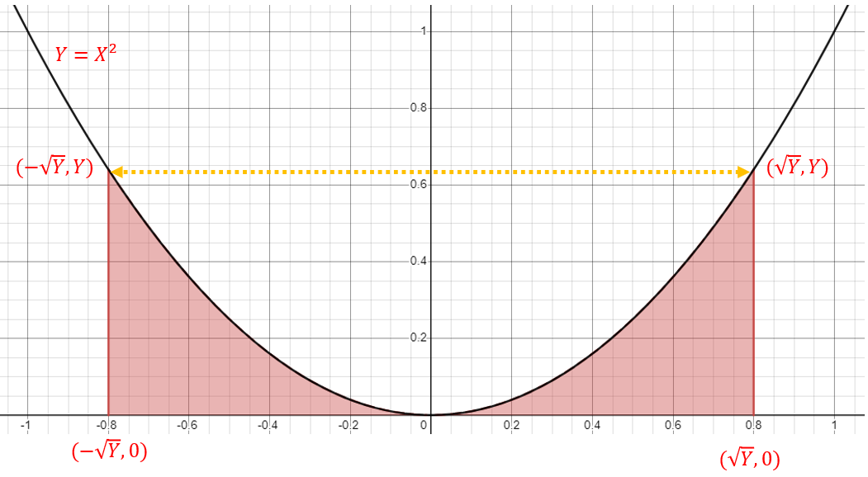

[](https://www.codecogs.com/eqnedit.php?latex=P(X%5E2%20%5Cleq%20y)%3DP(-%5Csqrt%7By%7D%20%5Cleq%20X%20%5Cleq%20%5Csqrt%7By%7D)#0)

Note that the probability being requested is related to the random variable [](https://www.codecogs.com/eqnedit.php?latex=X#0), so we need to use the PDF of [](https://www.codecogs.com/eqnedit.php?latex=X#0), [](https://www.codecogs.com/eqnedit.php?latex=f_X(x)#0).

[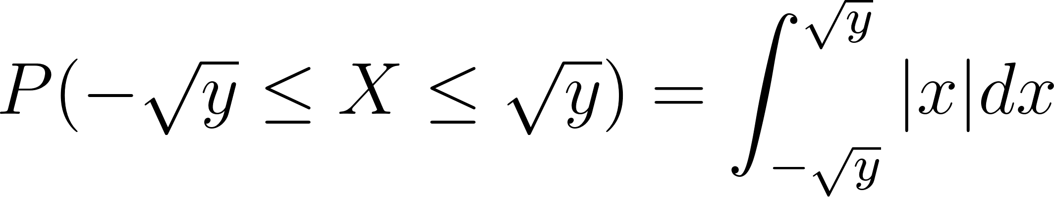](https://www.codecogs.com/eqnedit.php?latex=P(-%5Csqrt%7By%7D%20%5Cleq%20X%20%5Cleq%20%5Csqrt%7By%7D)%3D%5Cint_%7B-%5Csqrt%7By%7D%7D%5E%7B%5Csqrt%7By%7D%7D%7Cx%7C%20dx#0)

To integrate the absolute value function, recall the definition as absolute value as a piecewise function. When [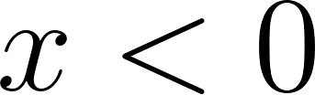](https://www.codecogs.com/eqnedit.php?latex=x%3C0#0), the function returns [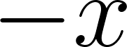](https://www.codecogs.com/eqnedit.php?latex=-x#0) and when [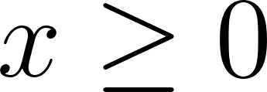](https://www.codecogs.com/eqnedit.php?latex=x%20%5Cgeq%200#0) the function returns [](https://www.codecogs.com/eqnedit.php?latex=x#0)

[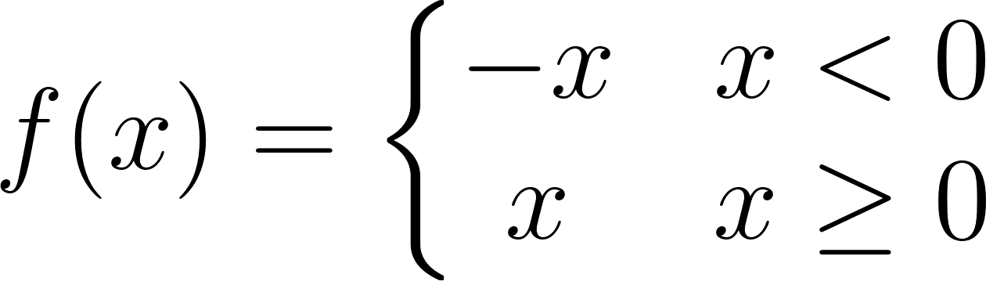](https://latex-staging.easygenerator.com/eqneditor/editor.php?latex=f(x)%3D%5Cleft%5C%7B%5Cbegin%7Bmatrix%7D%20-x%26x%20%3C0%20%5C%5C%20x%26%20x%5Cgeq%200%20%5Cend%7Bmatrix%7D%5Cright#0)

The integral can be split up at [](https://www.codecogs.com/eqnedit.php?latex=0#0) to account for this.

[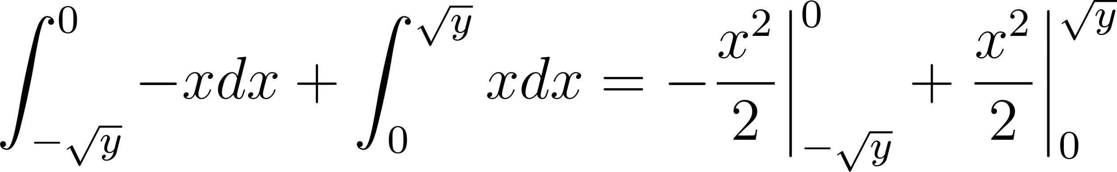](https://www.codecogs.com/eqnedit.php?latex=%5Cint_%7B-%5Csqrt%7By%7D%7D%5E%7B0%7D%20-x%20dx%20%2B%20%5Cint_%7B0%7D%5E%7B%5Csqrt%7By%7D%7D%20xdx%3D-%5Cdfrac%7Bx%5E2%7D%7B2%7D%20%5Cbigg%20%5Crvert_%7B-%5Csqrt%7By%7D%7D%5E%7B0%7D%20%2B%20%5Cdfrac%7Bx%5E2%7D%7B2%7D%20%5Cbigg%20%5Crvert_%7B0%7D%5E%7B%5Csqrt%7By%7D%7D#0)

[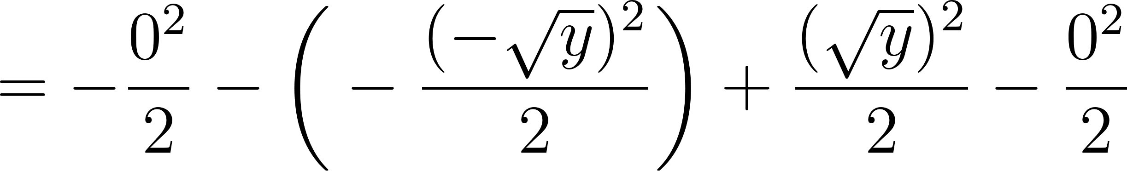](https://www.codecogs.com/eqnedit.php?latex=%3D-%5Cfrac%7B0%5E2%7D%7B2%7D-%5Cbigg(-%5Cfrac%7B(-%5Csqrt%7By%7D)%5E2%7D%7B2%7D%20%5Cbigg)%2B%5Cfrac%7B(%5Csqrt%7By%7D)%5E2%7D%7B2%7D-%5Cfrac%7B0%5E2%7D%7B2%7D#0)

[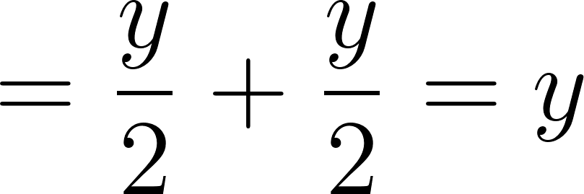](https://www.codecogs.com/eqnedit.php?latex=%3D%5Cfrac%7By%7D%7B2%7D%2B%5Cfrac%7By%7D%7B2%7D%3Dy#0)

The CDF of the random variable [](https://www.codecogs.com/eqnedit.php?latex=Y%3DX%5E2#0) is [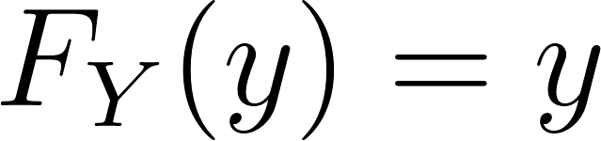](https://www.codecogs.com/eqnedit.php?latex=F_Y(y)%3Dy#0), [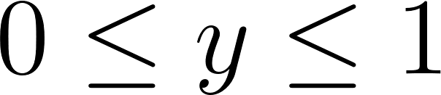](https://latex-staging.easygenerator.com/eqneditor/editor.php?latex=0%20%5Cleq%20y%20%5Cleq%201#0)

To find the PDF, take the derivative of the CDF. The PDF is [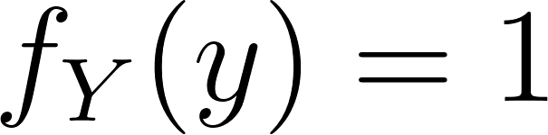](https://www.codecogs.com/eqnedit.php?latex=f_Y(y)%3D1#0), [](https://www.codecogs.com/eqnedit.php?latex=0%20%5Cleq%20y%20%5Cleq%201#0).

This is the PDF of a uniform random variable on the interval [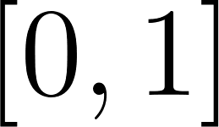](https://www.codecogs.com/eqnedit.php?latex=%5B0%2C%201%5D#0)

### Other Ways to Integrate Absolute Value

There are other ways of doing it using the sign function or taking the antiderivative of [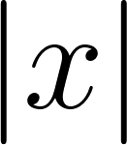](https://www.codecogs.com/eqnedit.php?latex=%7Cx%7C#0) as [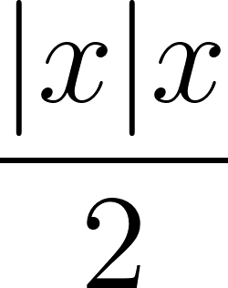](https://www.codecogs.com/eqnedit.php?latex=%5Cfrac%7B%7Cx%7Cx%7D%7B2%7D#0), but those aren't as clear to me personally.

#### Using the [sign function](https://en.wikipedia.org/wiki/Sign_function):

[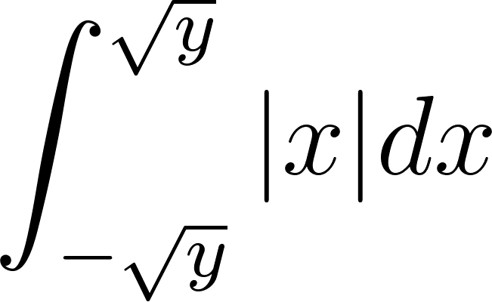](https://www.codecogs.com/eqnedit.php?latex=%5Cint_%7B-%5Csqrt%7By%7D%7D%5E%7B%5Csqrt%7By%7D%7D%7Cx%7Cdx#0)

[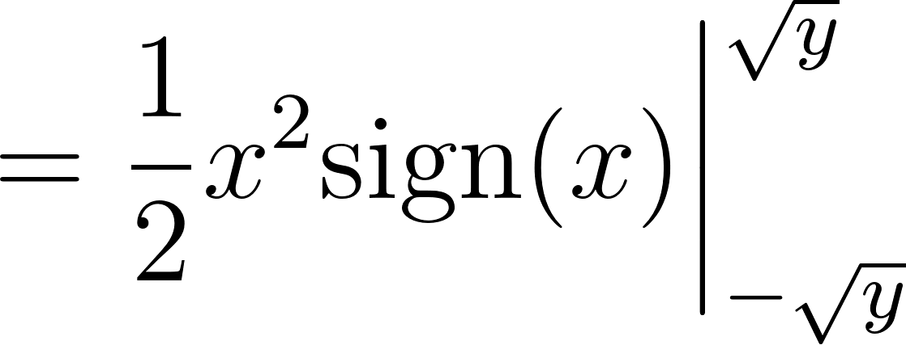](https://www.codecogs.com/eqnedit.php?latex=%3D%5Cfrac%7B1%7D%7B2%7Dx%5E2%20%5Ctextrm%7Bsign%7D(x)%20%5Cbigg%20%5Crvert_%7B-%5Csqrt%7By%7D%7D%5E%7B%5Csqrt%7By%7D%7D#0)

[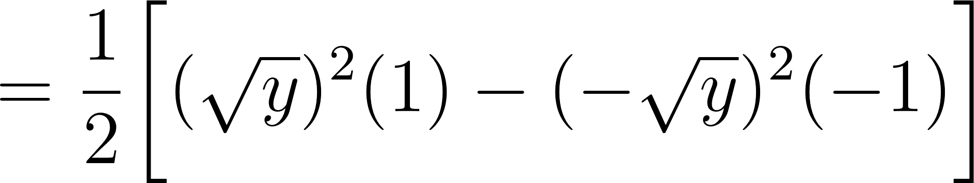](https://www.codecogs.com/eqnedit.php?latex=%3D%5Cfrac%7B1%7D%7B2%7D%20%5Cbigg%5B(%5Csqrt%7By%7D)%5E2(1)%20-%20(-%5Csqrt%7By%7D)%5E2(-1)%20%5Cbigg%5D#0)

[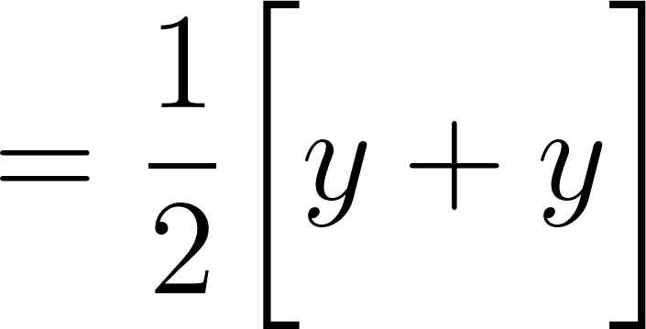](https://www.codecogs.com/eqnedit.php?latex=%3D%5Cfrac%7B1%7D%7B2%7D%5Cbigg%5By%2By%20%5Cbigg%5D#0)

[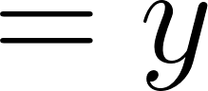](https://www.codecogs.com/eqnedit.php?latex=%3Dy#0)

#### Using absolute value of x times x over 2 as the antiderivative

[](https://www.codecogs.com/eqnedit.php?latex=%5Cint_%7B-%5Csqrt%7By%7D%7D%5E%7B%5Csqrt%7By%7D%7D%7Cx%7Cdx#0)

[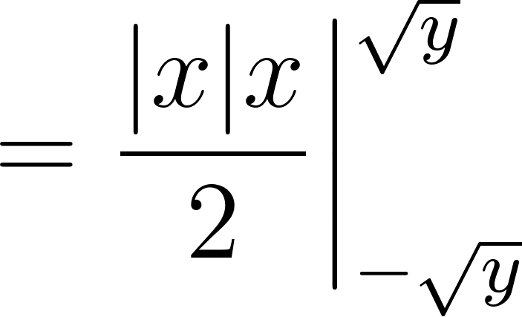](https://www.codecogs.com/eqnedit.php?latex=%3D%5Cfrac%7B%7Cx%7Cx%7D%7B2%7D%20%5Cbigg%20%5Crvert_%7B-%5Csqrt%7By%7D%7D%5E%7B%5Csqrt%7By%7D%7D#0)

[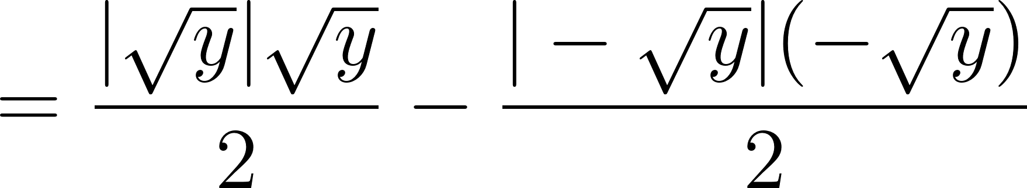](https://www.codecogs.com/eqnedit.php?latex=%3D%5Cfrac%7B%7C%5Csqrt%7By%7D%7C%5Csqrt%7By%7D%7D%7B2%7D-%5Cfrac%7B%7C-%5Csqrt%7By%7D%7C(-%5Csqrt%7By%7D)%7D%7B2%7D#0)

[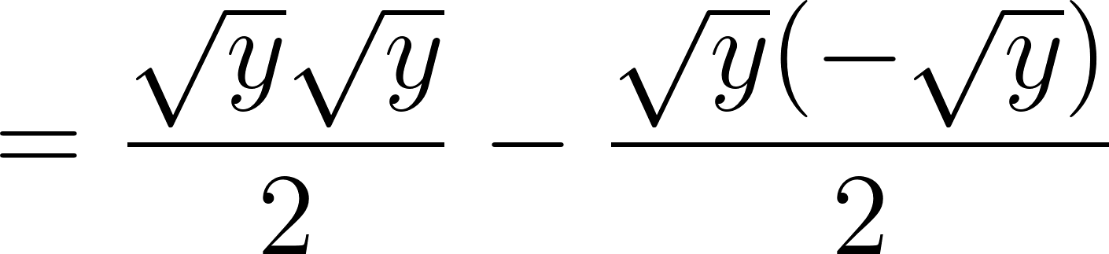](https://www.codecogs.com/eqnedit.php?latex=%3D%5Cfrac%7B%5Csqrt%7By%7D%5Csqrt%7By%7D%7D%7B2%7D-%5Cfrac%7B%5Csqrt%7By%7D(-%5Csqrt%7By%7D)%7D%7B2%7D#0)

[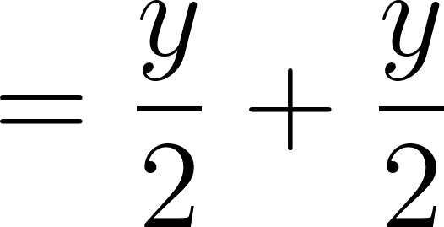](https://www.codecogs.com/eqnedit.php?latex=%3D%5Cfrac%7By%7D%7B2%7D%2B%5Cfrac%7By%7D%7B2%7D#0)

[](https://www.codecogs.com/eqnedit.php?latex=%3Dy%20#0)

#### Using symmetry

Here is another way of doing it by noticing that there is symmetry about the y-axis (thanks to Brian Kearney for this method).

[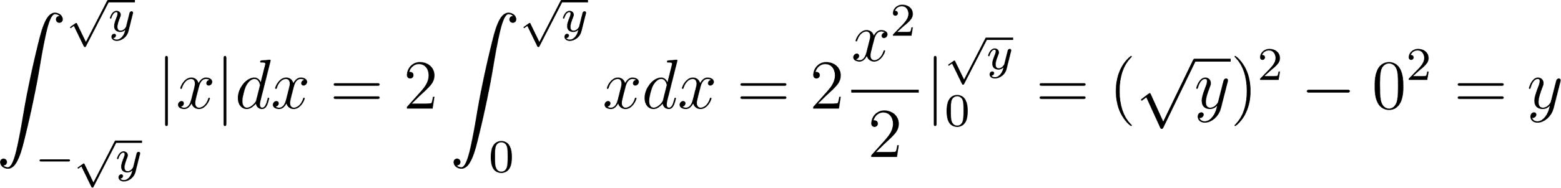](https://www.codecogs.com/eqnedit.php?latex=%5Cint_%7B-%5Csqrt%7By%7D%7D%5E%7B%5Csqrt%7By%7D%7D%7Cx%7Cdx%20%3D%202%5Cint_%7B0%7D%5E%7B%5Csqrt%7By%7D%7Dxdx%3D2%5Cfrac%7Bx%5E%7B2%7D%7D%7B2%7D%7C_%7B0%7D%5E%7B%5Csqrt%7By%7D%7D%20%3D%20(%5Csqrt%7By%7D)%5E%7B2%7D-0%5E%7B2%7D%20%3D%20y#0)

### Continuous Example R Code

set.seed(123)  
n <- 1e7  
  
U <- runif(n)  
X <- numeric(n)  
  
*# Generate abs(X) -1 <= x <= 1 using inverse transform (trust me)*  
X[U < 0.5] <- -sqrt(1 - 2*U[U < 0.5])  
X[U >= 0.5] <- sqrt(2*U[U >= 0.5] - 1)  
  
*# Plot the histogram of X with labels and customization*  
hist(X, 100,  
 main = "Histogram of X",  
 xlab = "X values",  
 ylab = "Frequency",  
 col = "blue",  
 border = "black")

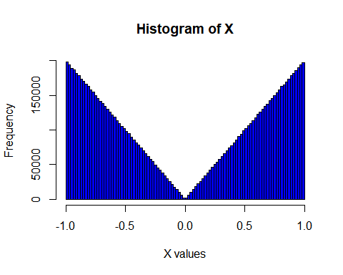

*# Transform using Y = X^2*  
Y <- X^2  
  
*# Plot the histogram of Y with labels and customization*  
hist(Y, 100,  
 main = "Histogram of Y",  
 xlab = "Y values",  
 ylab = "Frequency",  
 col = "red",  
 border = "black")

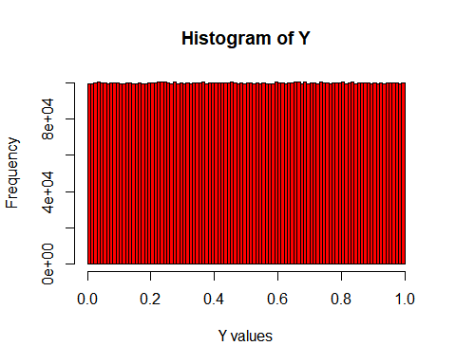

## Continuous Example Python Code

[Python Notebook](https://colab.research.google.com/drive/1rO_1iccsjGJA6azZ2h3-Lqx-vfFzD0M2)

# Inverse Transform Theorem

Suppose [](https://www.codecogs.com/eqnedit.php?latex=X#0) is a continuous random variable having CDF [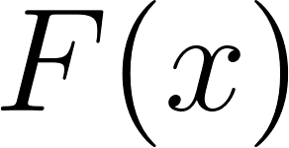](https://www.codecogs.com/eqnedit.php?latex=F(x)#0). The random variable [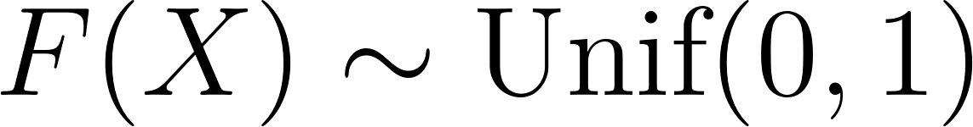](https://www.codecogs.com/eqnedit.php?latex=F(X)%20%5Csim%20%5Ctext%7BUnif%7D(0%2C1)#0). The random variable [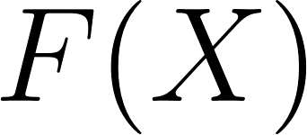](https://www.codecogs.com/eqnedit.php?latex=F(X)#0) is a function of a random variable and the same logic can be applied in order to prove this theorem.

Let [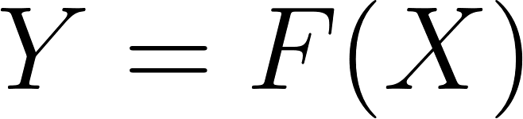](https://www.codecogs.com/eqnedit.php?latex=Y%3DF(X)#0) and calculate the CDF of [](https://www.codecogs.com/eqnedit.php?latex=Y#0).

[](https://www.codecogs.com/eqnedit.php?latex=P(Y%20%5Cleq%20y)%3DP(F_X(X)%20%5Cleq%20y)#0)

Apply the inverse in order to make the probability statement a statement using [](https://www.codecogs.com/eqnedit.php?latex=X#0).

[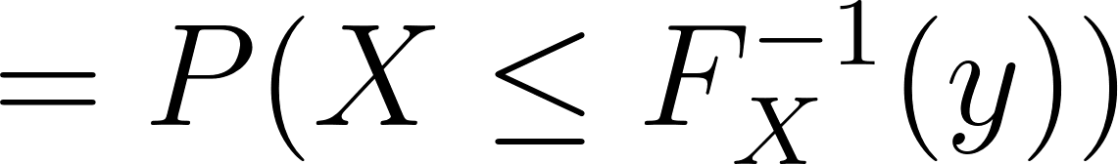](https://www.codecogs.com/eqnedit.php?latex=%3DP(X%20%5Cleq%20F_X%5E%7B-1%7D(y))#0)

The form [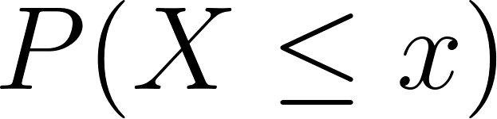](https://www.codecogs.com/eqnedit.php?latex=P(X%20%5Cleq%20x)#0) is the definition of the CDF of a random variable.

[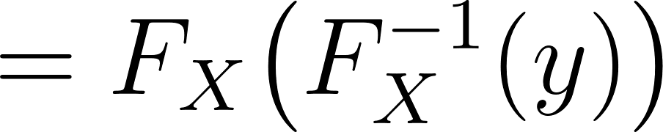](https://www.codecogs.com/eqnedit.php?latex=%3DF_X%20%5Cbig(F_X%5E%7B-1%7D(y)%20%5Cbig)#0).

Recall that if we were dealing with a concrete value such as [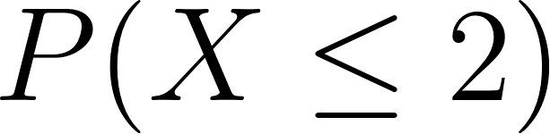](https://www.codecogs.com/eqnedit.php?latex=P(X%20%5Cleq%202)#0) this is equivalent to [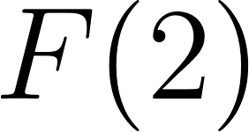](https://www.codecogs.com/eqnedit.php?latex=F(2)#0). In this case, replace the [](https://www.codecogs.com/eqnedit.php?latex=2#0) with [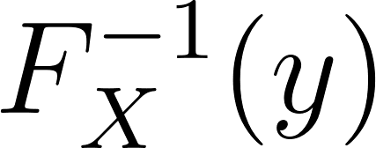](https://www.codecogs.com/eqnedit.php?latex=F_X%5E%7B-1%7D(y)#0).

The result is that we are applying a function and its inverse, so we are left with the function argument.

[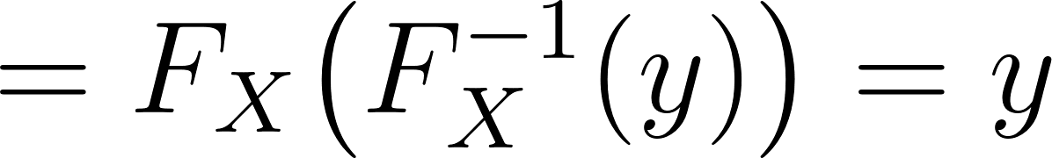](https://www.codecogs.com/eqnedit.php?latex=%3DF_X%20%5Cbig(F_X%5E%7B-1%7D(y)%20%5Cbig)%3Dy#0)

[](https://www.codecogs.com/eqnedit.php?latex=y#0) is the CDF of the uniform random distribution over the interval [](https://www.codecogs.com/eqnedit.php?latex=%5B0%2C%201%5D#0).

This leads to the procedure of setting [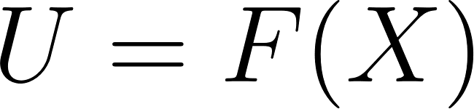](https://www.codecogs.com/eqnedit.php?latex=U%3DF(X)#0) and solving for [](https://www.codecogs.com/eqnedit.php?latex=X#0).

Review [M2L6 Simulating Random Variables](https://docs.google.com/document/u/0/d/1AACfyNV-Wvwz7XEcBw6y5brAJAZYR9vwMcqYkk3GDFw/edit) for an example using the inverse transform method.

# Bonus Time!

## Bonus Theorem

Review Section 2.8.3 in Goldsman, D. & Goldsman, P. (2020). A First Course in Probability and Statistics. Lulu. Download link

Applying this theorem to the example in the Continuous Example, we have [](https://www.codecogs.com/eqnedit.php?latex=f(x)%3D%7Cx%7C#0), [](https://www.codecogs.com/eqnedit.php?latex=-1%20%5Cleq%20x%20%5Cleq%201#0). Let [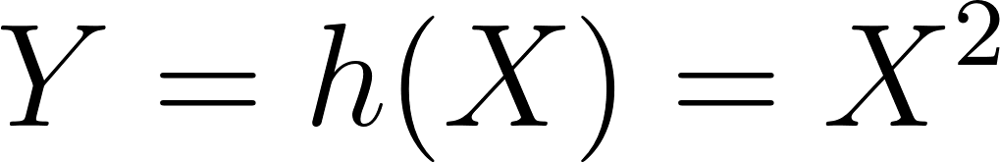](https://www.codecogs.com/eqnedit.php?latex=Y%3Dh(X)%3DX%5E2#0)

[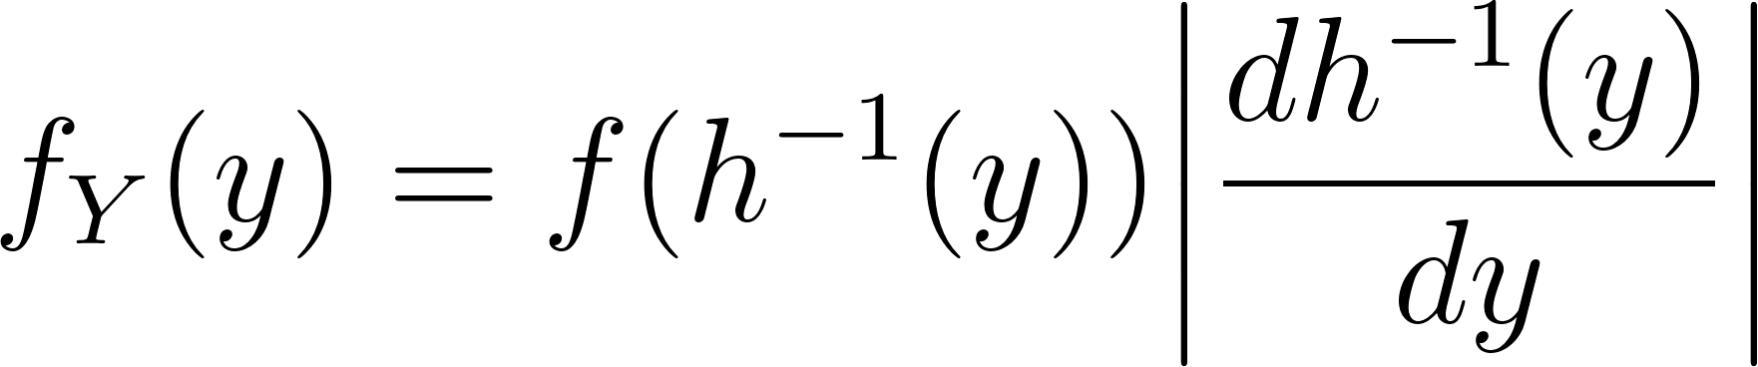](https://www.codecogs.com/eqnedit.php?latex=f_Y(y)%3Df(h%5E%7B-1%7D(y))%20%5Cbigg%20%7C%20%5Cdfrac%7Bd%20h%5E%7B-1%7D(y)%7D%7Bdy%7D%5Cbigg%20%7C#0)

[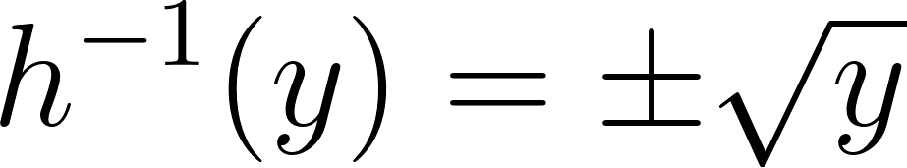](https://www.codecogs.com/eqnedit.php?latex=h%5E%7B-1%7D(y)%3D%5Cpm%20%5Csqrt%7By%7D#0)

We need to do this in two parts due to the nature of the absolute value function.

[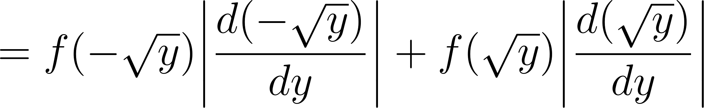](https://www.codecogs.com/eqnedit.php?latex=%3Df(-%5Csqrt%7By%7D)%20%5Cbigg%20%7C%20%5Cdfrac%7Bd%20(-%5Csqrt%7By%7D)%7D%7Bdy%7D%5Cbigg%20%7C%2Bf(%5Csqrt%7By%7D)%20%5Cbigg%20%7C%20%5Cdfrac%7Bd%20(%5Csqrt%7By%7D)%7D%7Bdy%7D%5Cbigg%20%7C#0)

[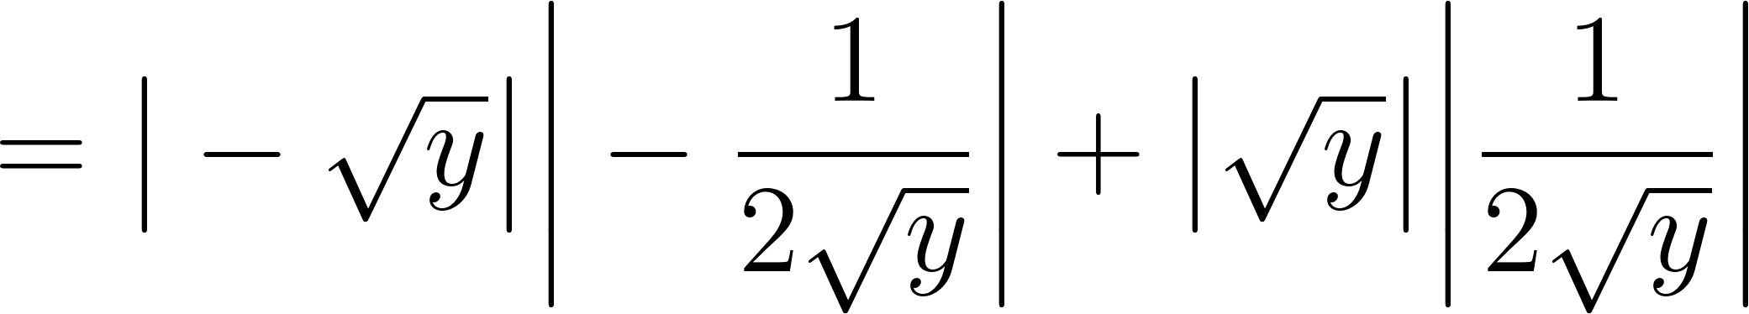](https://www.codecogs.com/eqnedit.php?latex=%3D%5Cbig%7C%20-%5Csqrt%7By%7D%20%5Cbig%20%7C%20%5Cbigg%20%7C-%5Cdfrac%7B1%7D%7B2%5Csqrt%7By%7D%7D%20%5Cbigg%20%7C%2B%20%5Cbig%20%7C%20%5Csqrt%7By%7D%20%5Cbig%20%7C%20%5Cbigg%20%7C%5Cdfrac%7B1%7D%7B2%5Csqrt%7By%7D%7D%20%5Cbigg%20%7C#0)

[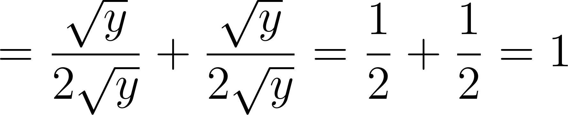](https://www.codecogs.com/eqnedit.php?latex=%3D%5Cdfrac%7B%5Csqrt%7By%7D%7D%7B2%5Csqrt%7By%7D%7D%2B%5Cdfrac%7B%5Csqrt%7By%7D%7D%7B2%5Csqrt%7By%7D%7D%3D%5Cdfrac%7B1%7D%7B2%7D%2B%5Cdfrac%7B1%7D%7B2%7D%3D1#0)

This is the same result that was obtained using the other method of finding the CDF of [](https://www.codecogs.com/eqnedit.php?latex=Y#0) and then finding its derivative.

## LOTUS Proof

[](https://www.codecogs.com/eqnedit.php?latex=f_X(x)#0) is the PDF of the random variable [](https://www.codecogs.com/eqnedit.php?latex=X#0).

[](https://www.codecogs.com/eqnedit.php?latex=Y%3Dh(X)#0) is a new random variable which is a function of [](https://www.codecogs.com/eqnedit.php?latex=X#0).

[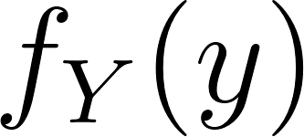](https://www.codecogs.com/eqnedit.php?latex=f_Y(y)#0) is the PDF of the random variable [](https://www.codecogs.com/eqnedit.php?latex=Y#0)

Let [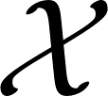](https://www.codecogs.com/eqnedit.php?latex=%5Cmathcal%7BX%7D#0) be the possible outcomes of [](https://www.codecogs.com/eqnedit.php?latex=X#0) and [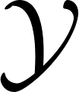](https://www.codecogs.com/eqnedit.php?latex=%5Cmathcal%7BY%7D#0) be the possible outcomes of [](https://www.codecogs.com/eqnedit.php?latex=Y#0).

[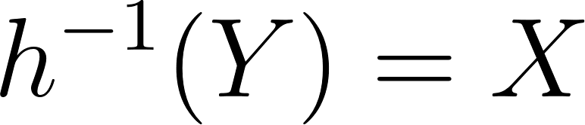](https://www.codecogs.com/eqnedit.php?latex=h%5E%7B-1%7D(Y)%3DX#0) due to the definition of inverse functions.

[Taking the derivative of this yields](https://math.libretexts.org/Bookshelves/Calculus/Calculus_(OpenStax)/03%3A_Derivatives/3.07%3A_Derivatives_of_Inverse_Functions):

[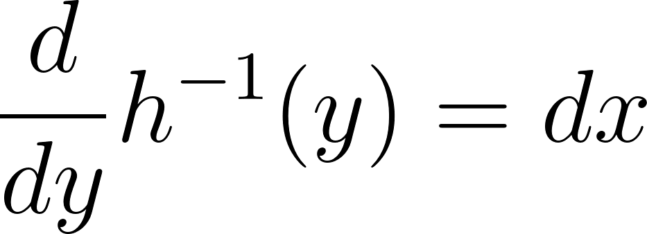](https://www.codecogs.com/eqnedit.php?latex=%5Cdfrac%7Bd%7D%7Bdy%7Dh%5E%7B-1%7D(y)%3Ddx#0)

[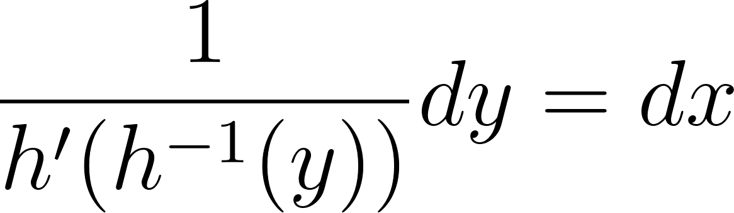](https://www.codecogs.com/eqnedit.php?latex=%5Cdfrac%7B1%7D%7Bh'(h%5E%7B-1%7D(y))%7Ddy%3Ddx#0)

Start with finding the expected value of [](https://www.codecogs.com/eqnedit.php?latex=Y#0) which is a function of the random variable [](https://www.codecogs.com/eqnedit.php?latex=X#0).

[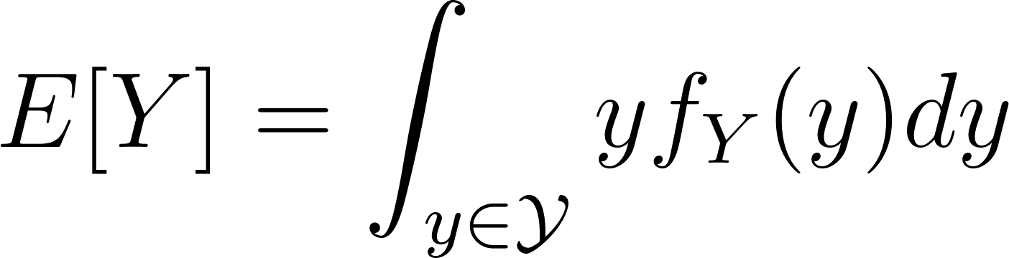](https://www.codecogs.com/eqnedit.php?latex=E%5BY%5D%3D%5Cint_%7By%20%5Cin%20%5Cmathcal%7BY%7D%7D%20y%20f_Y(y)dy#0)

Substitute for [](https://www.codecogs.com/eqnedit.php?latex=f_Y(y)#0) using the Bonus Theorem above.

[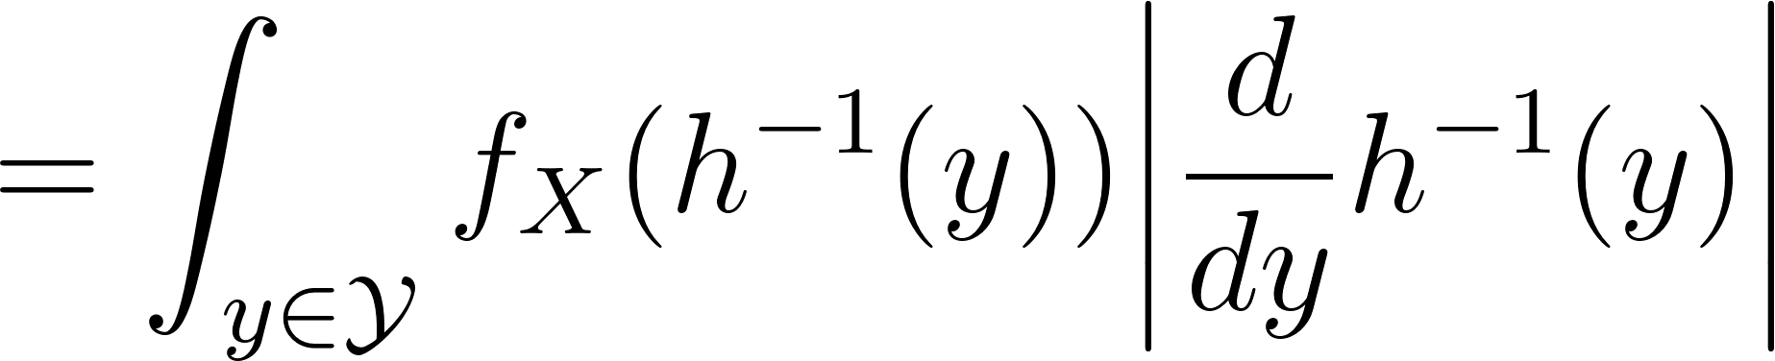](https://www.codecogs.com/eqnedit.php?latex=%3D%5Cint_%7By%20%5Cin%20%5Cmathcal%7BY%7D%7D%20f_X(h%5E%7B-1%7D(y))%20%5Cbigg%20%7C%5Cdfrac%7Bd%7D%7Bdy%7Dh%5E%7B-1%7D(y)%20%5Cbigg%20%7C#0)

Use the result of the derivative of [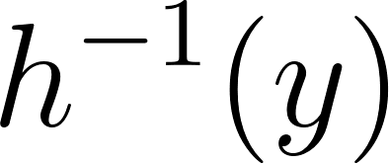](https://www.codecogs.com/eqnedit.php?latex=h%5E%7B-1%7D(y)#0)

[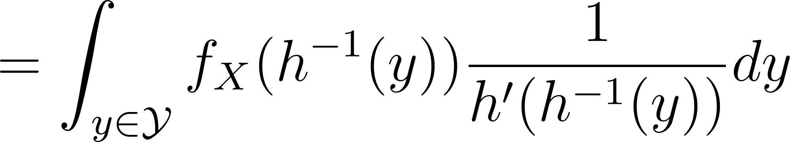](https://www.codecogs.com/eqnedit.php?latex=%3D%5Cint_%7By%20%5Cin%20%5Cmathcal%7BY%7D%7D%20f_X(h%5E%7B-1%7D(y))%20%5Cdfrac%7B1%7D%7Bh'(h%5E%7B-1%7D(y))%7Ddy#0)

Substitute in [](https://www.codecogs.com/eqnedit.php?latex=x#0) for [](https://www.codecogs.com/eqnedit.php?latex=h%5E%7B-1%7D(y)#0) and [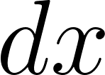](https://www.codecogs.com/eqnedit.php?latex=dx#0) for the derivative of the inverse function.

[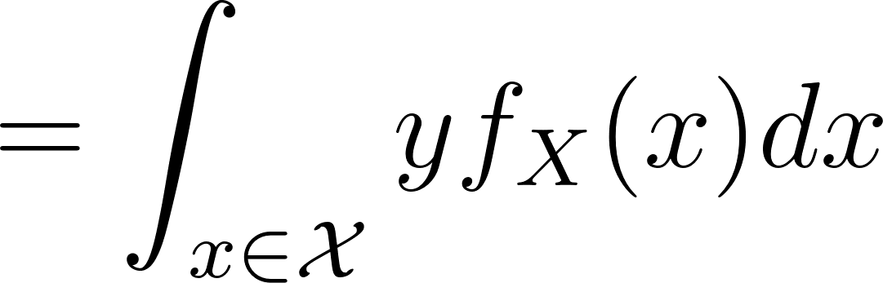](https://www.codecogs.com/eqnedit.php?latex=%3D%5Cint_%7Bx%20%5Cin%20%5Cmathcal%7BX%7D%7D%20y%20f_X(x)dx#0)

Substitute in for [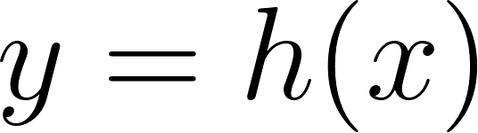](https://www.codecogs.com/eqnedit.php?latex=y%3Dh(x)#0)

[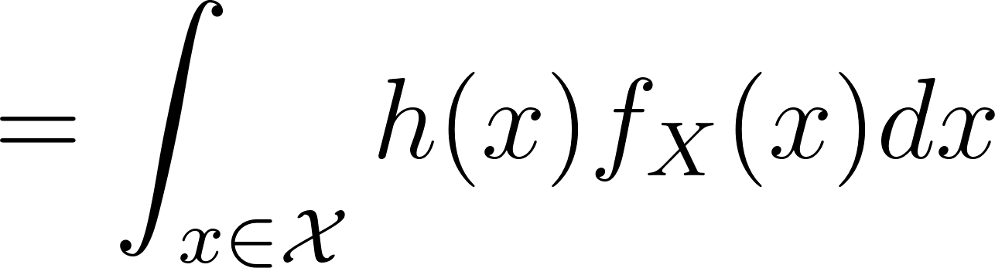](https://www.codecogs.com/eqnedit.php?latex=%3D%5Cint_%7Bx%20%5Cin%20%5Cmathcal%7BX%7D%7D%20h(x)%20f_X(x)dx#0)

Thus [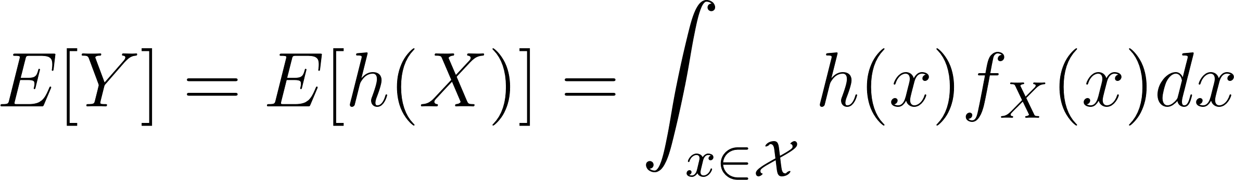](https://www.codecogs.com/eqnedit.php?latex=E%5BY%5D%3DE%5Bh(X)%5D%3D%5Cint_%7Bx%20%5Cin%20%5Cmathcal%7BX%7D%7D%20h(x)%20f_X(x)dx#0)